**Team ID : PNT2022TMID30007**

# Setting up Application Environment Install IBM Cloud CLI

**Step 1.** Navigate to cloud.ibm.com

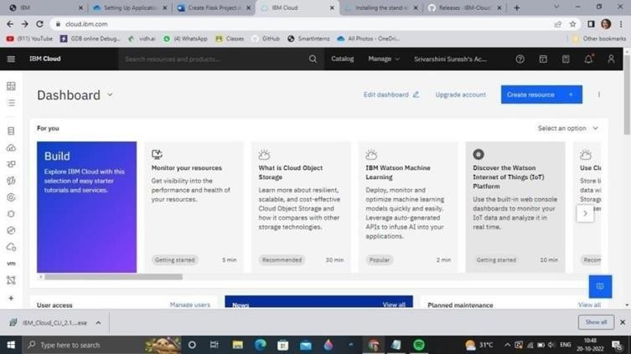

**Step 2.** Search on Container Registry and give get started and follow the steps to install IBM Cloud CLI

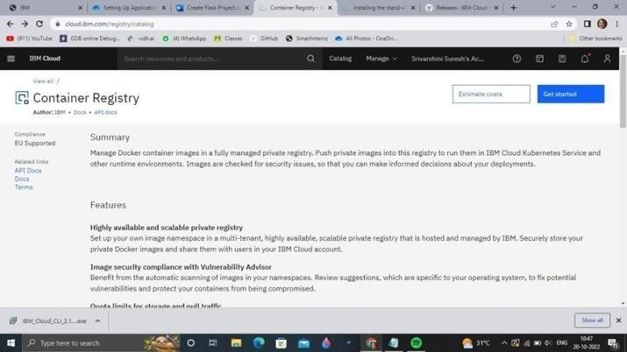

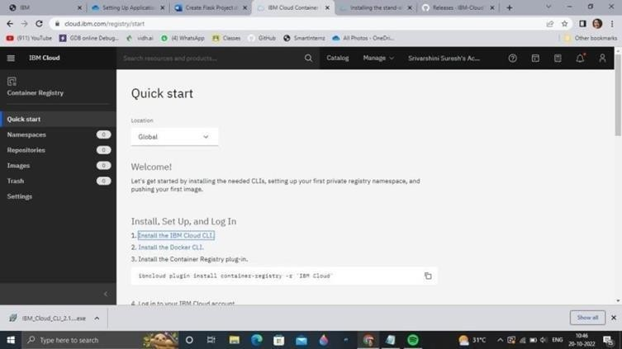

**Step 3.**Download windows 64 bit installer

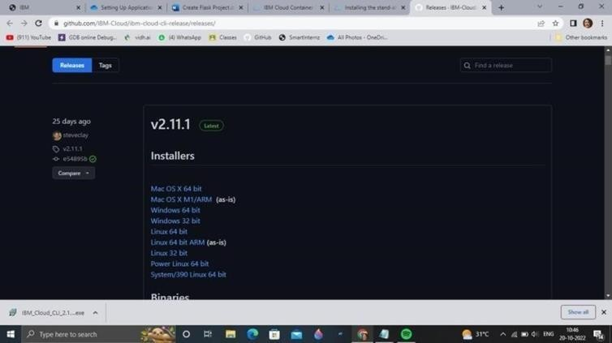

**Step 4**. Open the downloaded .exe file and run it to install IBM Cloud CLI

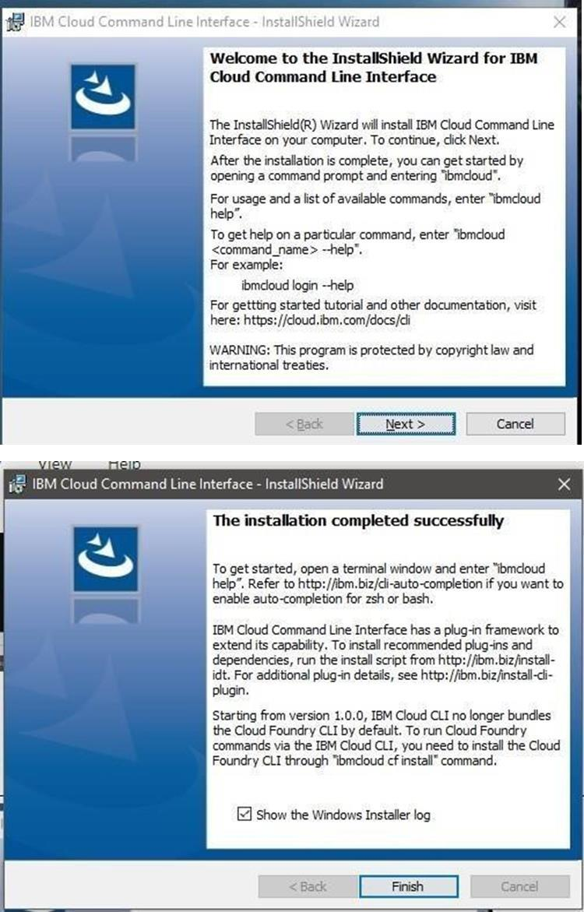

# OUTPUT:

IBM Cloud CLI is installed successfully